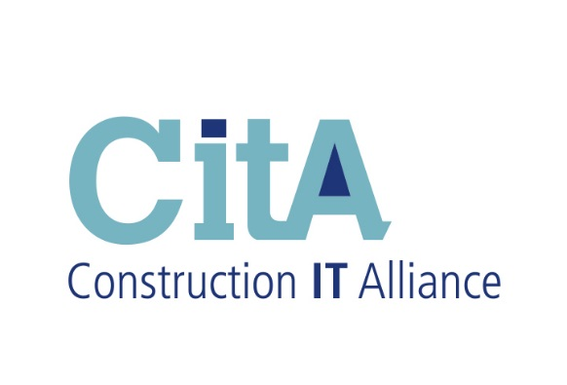

CitA BIM Gathering 2019

TRANSFER OF COPYRIGHT AGREEMENT

The Article Entitled: ______________________________________________________________________

has been submitted for publication in the proceedings of the CitA BIM Gathering 2019. I, as an Author, and on behalf of any other authors, hereby declare that it contains no material that is plagiaristic, or otherwise contrary to law, and agree to assign irrevocably to CitA the entire copyright (with the exception of copyright in third party materials included in the Article) in the Article.

Except that the Author (s) shall retain:

1. All proprietary rights other than copyright, such as patent rights
2. The right to make further copies of all or part of the article for educational use
3. The right to reuse this material in further articles or works textbooks
4. The right to make copies of the published work for internal distribution within my institution
5. The right to publish the paper in a peer reviewed academic journal.

I agree to inform my co-authors, if any, of the above terms. I certify that I have obtained written
Permission(s) for the use of text, tables, and/or illustrations from any copyrighted source(s) and I agree to supply such written permission(s) to the organisers of the CitA BIM Gathering 2019 upon request.

Electronic signature is acceptable. Otherwise, sign and scan to spurcell@cita.ie

Signed by (Block Letters):  Signature: |  | Date:
Institution/Company

